To run Musicalgorithms3.0, a web server is needed. The following link http://ndever.net/articles/linux/install-lamp-server-ubuntu-1210-1304 has some instructions on how to install LAMP on Ubuntu 13.10.

Once LAMP is installed, open a browser and type “http://127.0.0.1/” in the URL. You should see what is in the image below if everything is working correctly.

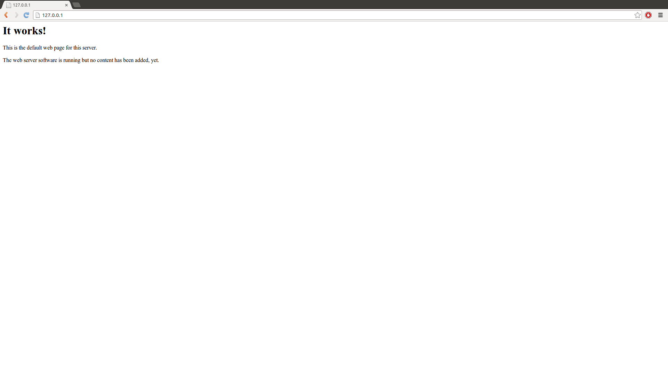
Make sure to change permission in “/var/www” folder in your machine. The terminal command is:
chmod -R 755 /var/www

After permissions has been change, browse to the folder containing the source code of the project.

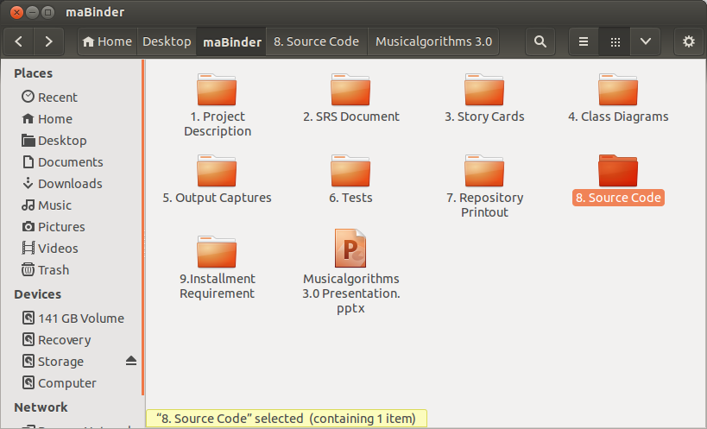

Browse to MusicAlgorithmBinder.
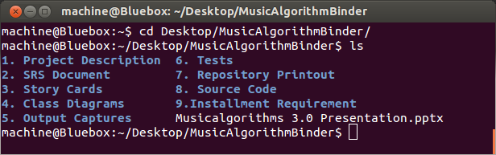
Now you must copy all the contents from “8. Source Code” to “/var/www” folder on your machine.

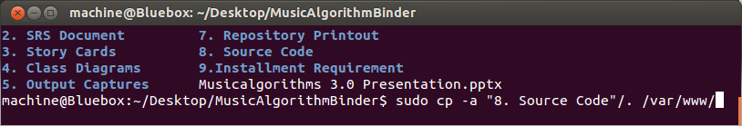
If there are any “403 Forbidden Error”, use “chmod -R 755 /var/www” once more on the “/var/www” folder. It is also very helpful to use a console debugger to see errors.

When the setup is complete and correct you should see the following screen below. Your screen may not show the debugger console if it is not enabled in you browser.
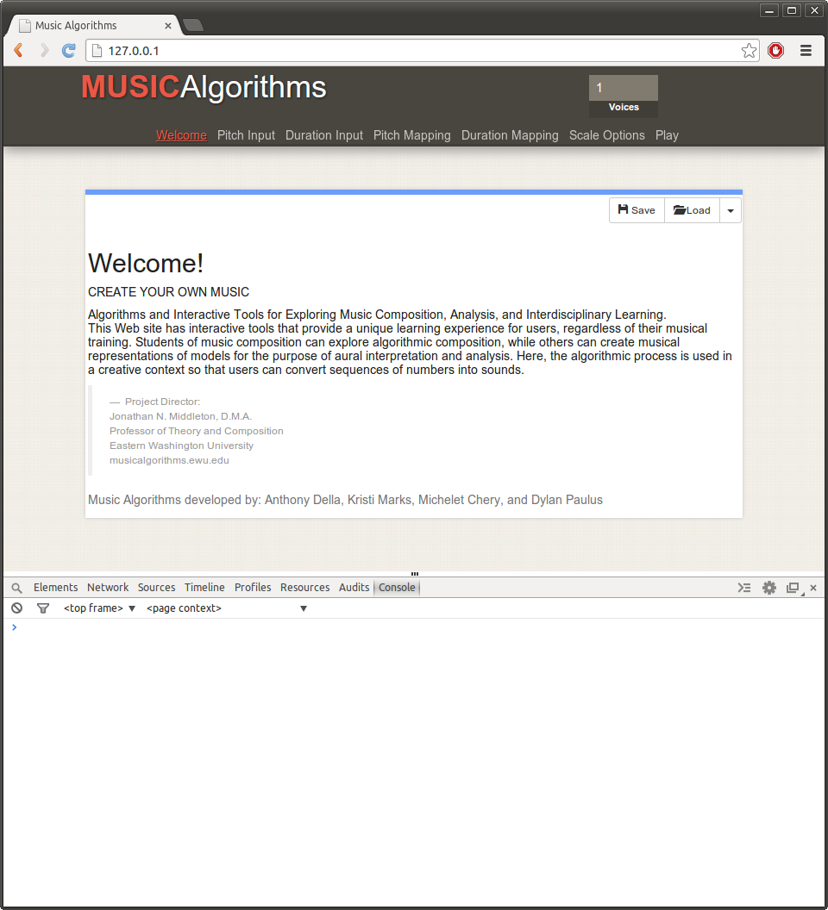

Since setup is complete, you are now free to use the program.

